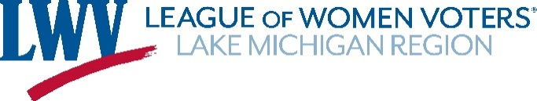

Dues Remittance for Fiscal Year Ending June 30, 2021

Local or State League Name: ______________________________________________________

League Mailing Address: _________________________________________________________

President’s Name: __________________________________ Phone: ______________________
Email: ________________________________________
Treasurer’s Name: ____________________________ Email: ____________________________

Natural Resources Chair Name: ___________________________________________________

Email: __________________________________

Number of members in your League as of January 31, 2020: _______

Dues Schedule
Fewer than 50 members $25
50-100 members $40
Over 100 members $50

2020 – 2021 Dues $ ________
Additional Donation $_________
TOTAL Enclosed $_________

PLEASE MAIL this form with a check payable to LWVLMR to:
League of Women Voters Lake Michigan Region
332 S. Michigan Avenue, Suite 634
Chicago, IL 60604

Thank you for your membership in LWV Lake Michigan Region!

